# Automatic Labelling and Model Tuning with Amazon SageMaker

Developing machine learning models requires a lot of effort which often needs to be repeated over time as data distributions change. In this session you will learn about some of the latest concepts in Automatic Machine Learning including how to apply them to speed up development and achieve robust models over time. You will learn how to run a custom labelling job using Amazon SageMaker GroundTruth to build a data set to fine-tune your model. You will also learn how to tune your model’s hyperparameters using SageMaker’s Automatic Model Tuning capabilities and understand the theory of how Bayesian Optimisation is automatically applied for more accurate results and faster tuning.

[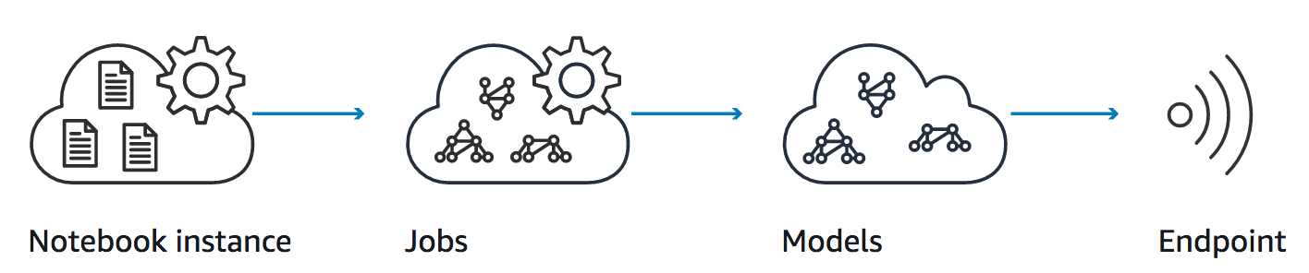](https://github.com/adamrb/amazon-sagemaker-workshop/blob/master/images/overview.png)

# **Prerequisites**

## AWS Account

In order to complete this workshop you'll need an AWS Account with access to create AWS IAM, S3 and SageMaker resources. The code and instructions in this workshop assume only one student is using a given AWS account at a time. If you try sharing an account with another student, you'll run into naming conflicts for certain resources. You can work around these by appending a unique suffix to the resources that fail to create due to conflicts, but the instructions do not provide details on the changes required to make this work.

Some of the resources you will launch as part of this workshop are eligible for the AWS free tier if your account is less than 12 months old. See the [AWS Free Tier page](https://aws.amazon.com/free/) for more details. For other resources AWS credit vouchers are supplied.

## AWS Region

SageMaker is not available in all AWS Regions at this time. Accordingly, we recommend running this workshop in one of the following supported AWS Regions: N. Virginia, Oregon, Ohio, or Ireland.

Once you've chosen a region, you should create all of the resources for this workshop there, including a new Amazon S3 bucket and a new SageMaker notebook instance. Make sure you select your region from the dropdown in the upper right corner of the AWS Console before getting started.

[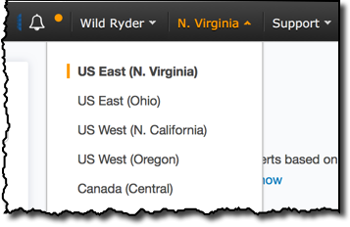](https://github.com/adamrb/amazon-sagemaker-workshop/blob/master/images/region-selection.png)

## Browser

We recommend you use the latest version of Chrome or Firefox to complete this workshop.

## **Modules**

This workshop is divided into multiple labs. Lab 1 must be completed first, followed by Lab 2.

1. Automatic Labelling
2. Private Workforce Labelling
3. Automatic Model Tuning

# In this lab, you will use Amazon SageMaker Ground Truth to label images in a training dataset. You will start with an unlabeled image training data set, acquire labels for all the images using SageMaker Ground Truth private workforce and finally analyze the results of the labeling job.

# **High Level Steps**

1. Upload training data into an S3 bucket.
2. Create a private Ground Truth Labeling workforce.
3. Create a Ground Truth Labeling job
4. Label the images using the Ground Truth Labeling portal.
5. Analyze results

Some parts of the lab have instructions in the Jupyter notebook .Be patient as you work your way through the notebook-based modules. After you run a cell in a notebook, it may take several seconds for the code to show results. For the cells that start training jobs, it may take several minutes. In particular, the last two modules have training jobs that may last up to 10 minutes.

After you have completed the workshop, you can delete all of the resources that were created by following the Cleanup Guide provided with this lab guide.

## **Lab 1: Automatic Model Tuning with Amazon Sagemaker GroundTruth**

In this module we'll start by requesting a limit increase for ml.p3.2xlarge instances with can optionally be used at the end of the lab for training an object detection model. Then we will create an Amazon S3 bucket that will be used throughout the workshop. We'll then create a SageMaker notebook instance, which we will use to run the other workshop modules.

To begin, sign into the AWS Management Console, <https://console.aws.amazon.com/>.

### 1. Requesting Limit Increase

Amazon SageMaker by default limits access to GPU instances. Our first task is to use the console to request a limit increase:

1. Open the [AWS Support Center](https://console.aws.amazon.com/support/home#/) page by clicking in the top right of the console, sign in if necessary, and choose **Create case**.
2. Choose **Service limit increase**.
3. Under Limit type select ‘SageMaker’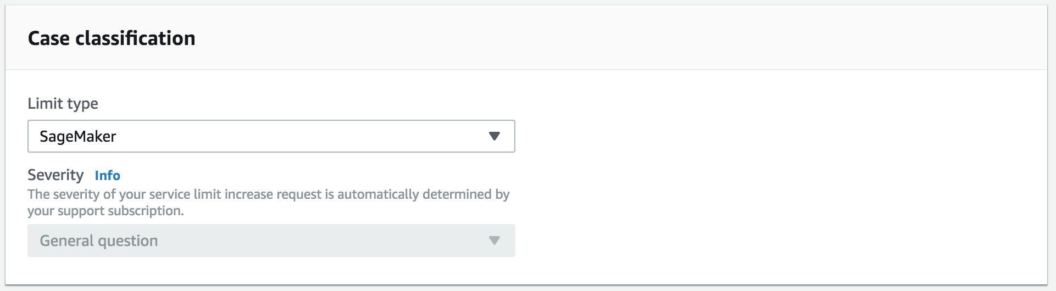
4. Select the following under Requests (with your region of choice for this workshop):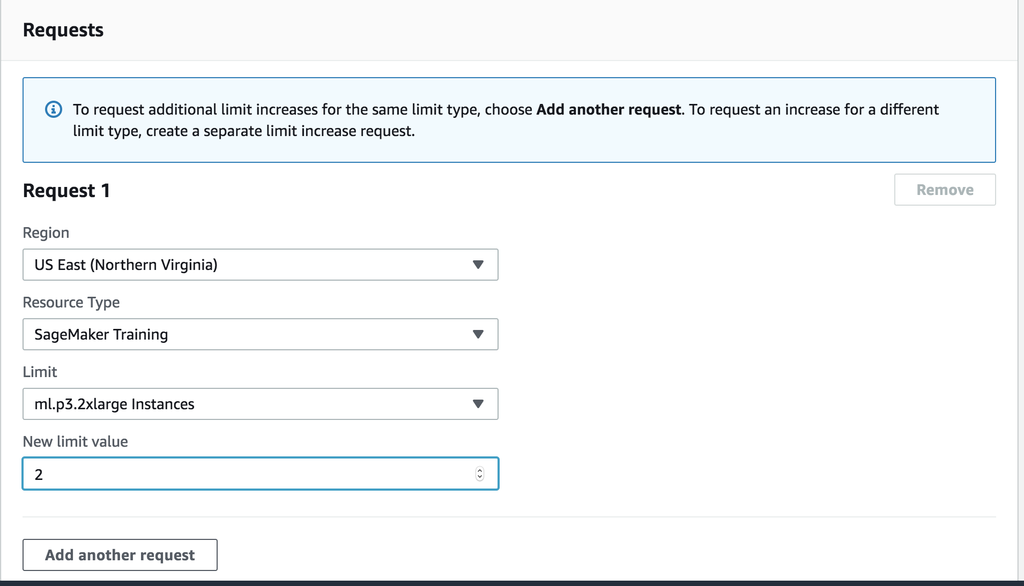
5. Under Use Case Description type ‘Urgent request for Sydney Summit workshop’.
6. Choose **Submit**.
7. This may come through before you reach the end of this lab, in which case you can train a model using the labelled images, otherwise come back to the training later.

### 2. Create a S3 Bucket

SageMaker typically uses S3 as storage for data and model artifacts. In this step you'll create a S3 bucket for this purpose.

#### High-Level Instructions

Use the console or AWS CLI to create an Amazon S3 bucket. Keep in mind that your bucket's name must be globally unique across all regions and customers. We recommend using a name like sagemakerworkshop-firstname-lastname. If you get an error that your bucket name already exists, try adding additional numbers or characters until you find an unused name.

* Create an S3 Bucket (Put sagemaker) in the name
* Use North Virginia
* Click next accepting defaults all the way to finish

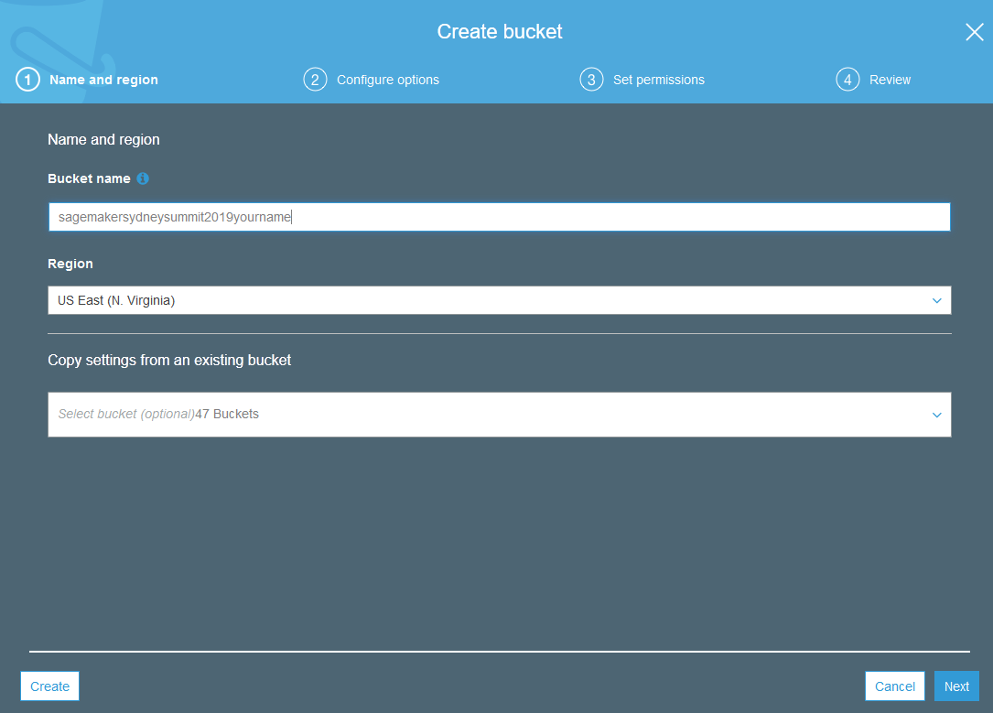

**Step-by-step instructions**

Nltcgnegitugtgvucnnihclkvcleuddjtb

### 3. Launching the Notebook Instance

1. In the upper-right corner of the AWS Management Console, confirm you are in the desired AWS region. Select N. Virginia, Oregon, Ohio, or Ireland.
2. Click on Amazon SageMaker from the list of all services. This will bring you to the Amazon SageMaker console homepage.

[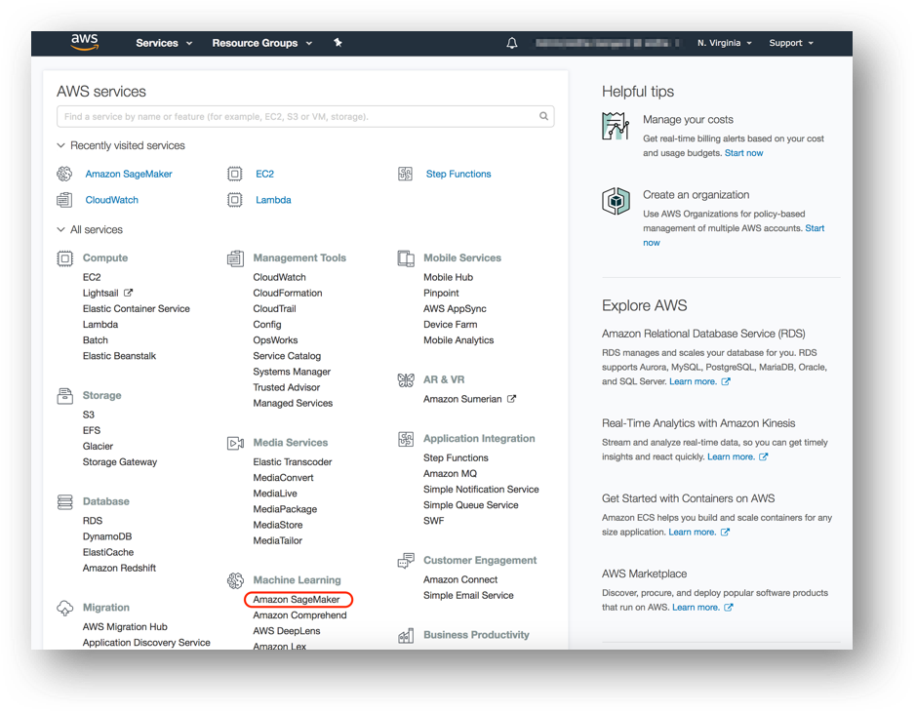](https://github.com/adamrb/amazon-sagemaker-workshop/blob/master/images/Picture1.png)

1. To create a new notebook instance, go to **Notebook instances**, and click the **Create notebook instance** button at the top of the browser window.

[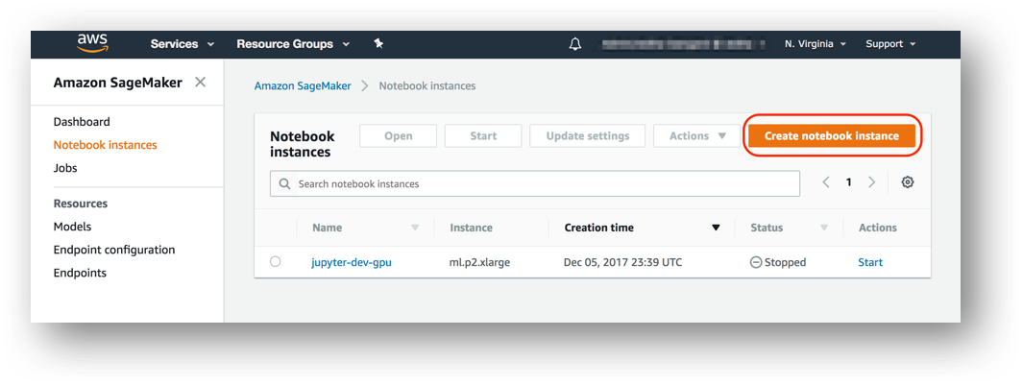](https://github.com/adamrb/amazon-sagemaker-workshop/blob/master/images/Picture2.png)

1. Type [First Name]-[Last Name]-workshop into the **Notebook instance name** text box, and select ml.m4.xlarge for the **Notebook instance type**. (Or t2.meduim if your account is not allowing m4)
2. For IAM role, choose **Select an existing role** and choose one named "AmazonSageMaker-ExecutionRole-XXXX".

**NOTE: If ROLE does not exist chose “Create new role”**

1. **Choose Create a new role. Choose Any S3 Bucket**

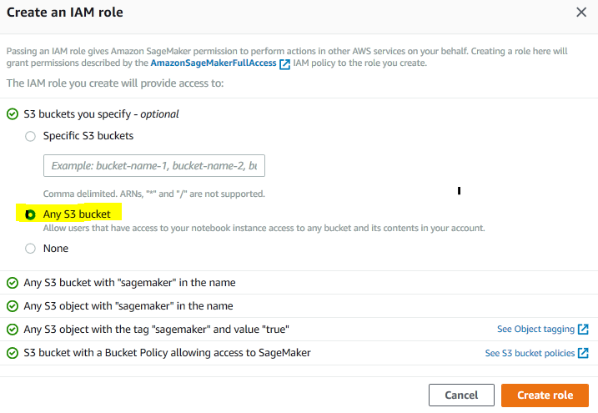

1. Accept Defaults for VPC and volume size
2. Click Create Notebook instance

[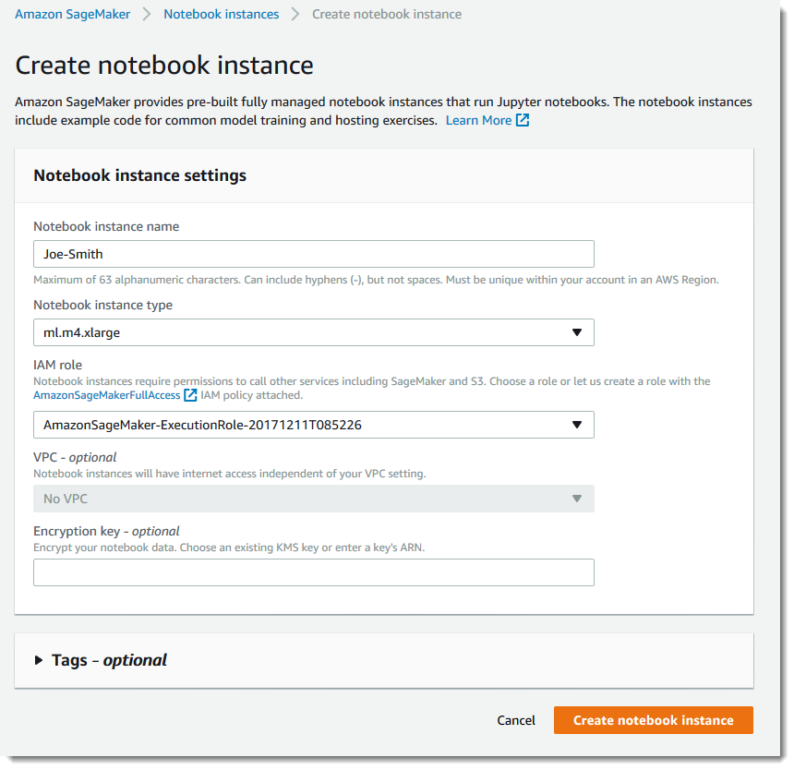](https://github.com/adamrb/amazon-sagemaker-workshop/blob/master/images/create-instance.png)

1. You can expand the "Tags" section and add tags here if required.
2. Under Git Repositories select ‘Clone a Git repository to this notebook instance only’
3. Enter **https://github.com/Aashmeet/ML-groundtruth.git**
4. https://github.com/Aashmeet/ML-groundtruth
5. under the ‘Git repository URL’. This will automatically clone the resources required for the workshop into the notebook instance.

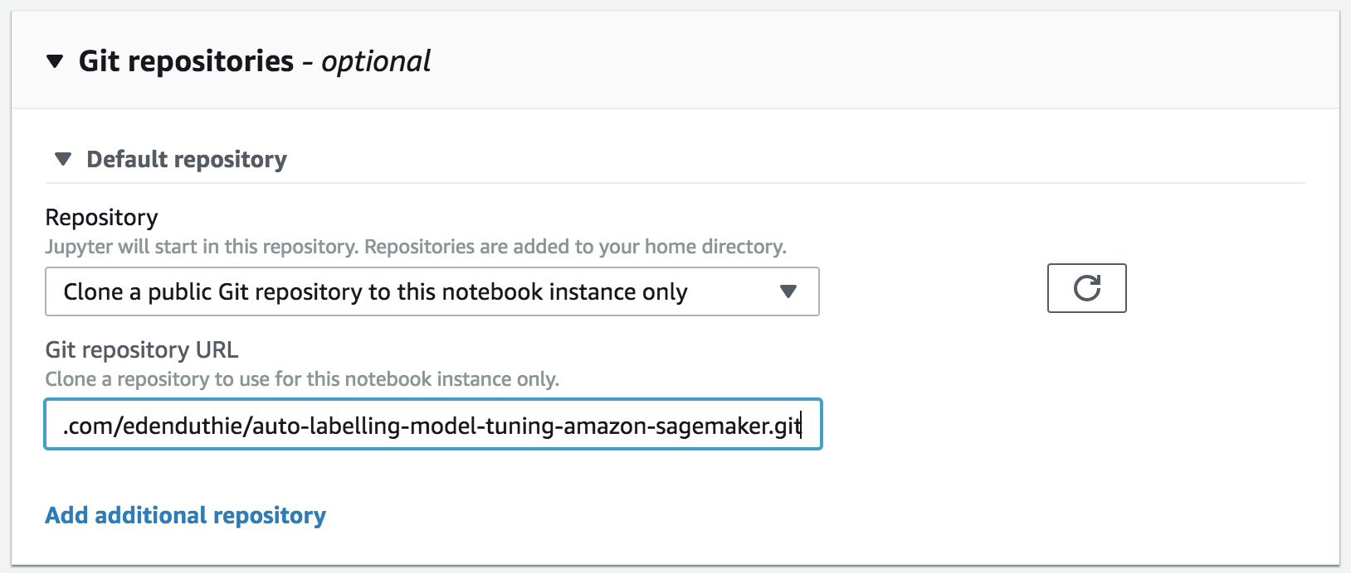

12. You will be taken back to the Create Notebook instance page. Click **Create notebook instance**. This will take several minutes to complete.

### 4. Accessing the Notebook Instance

1. Wait for the server status to change to **InService**. This will take a few minutes.

[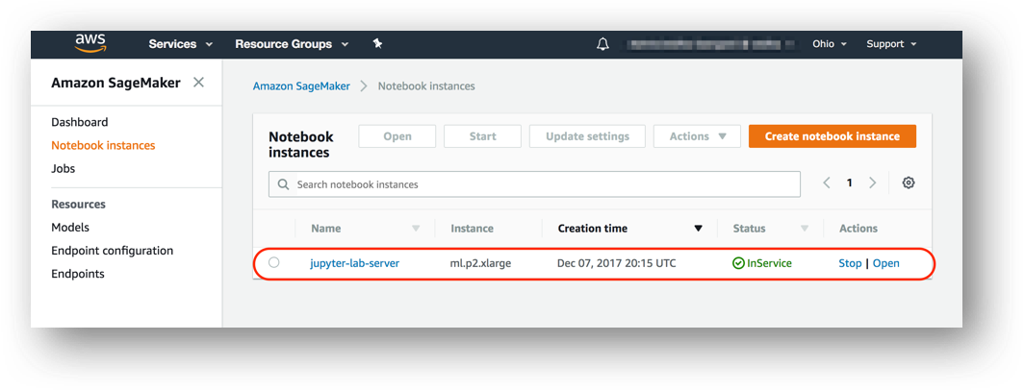](https://github.com/adamrb/amazon-sagemaker-workshop/blob/master/images/Picture4.png)

1. Click **Open**. You will now see the Jupyter homepage for your notebook instance.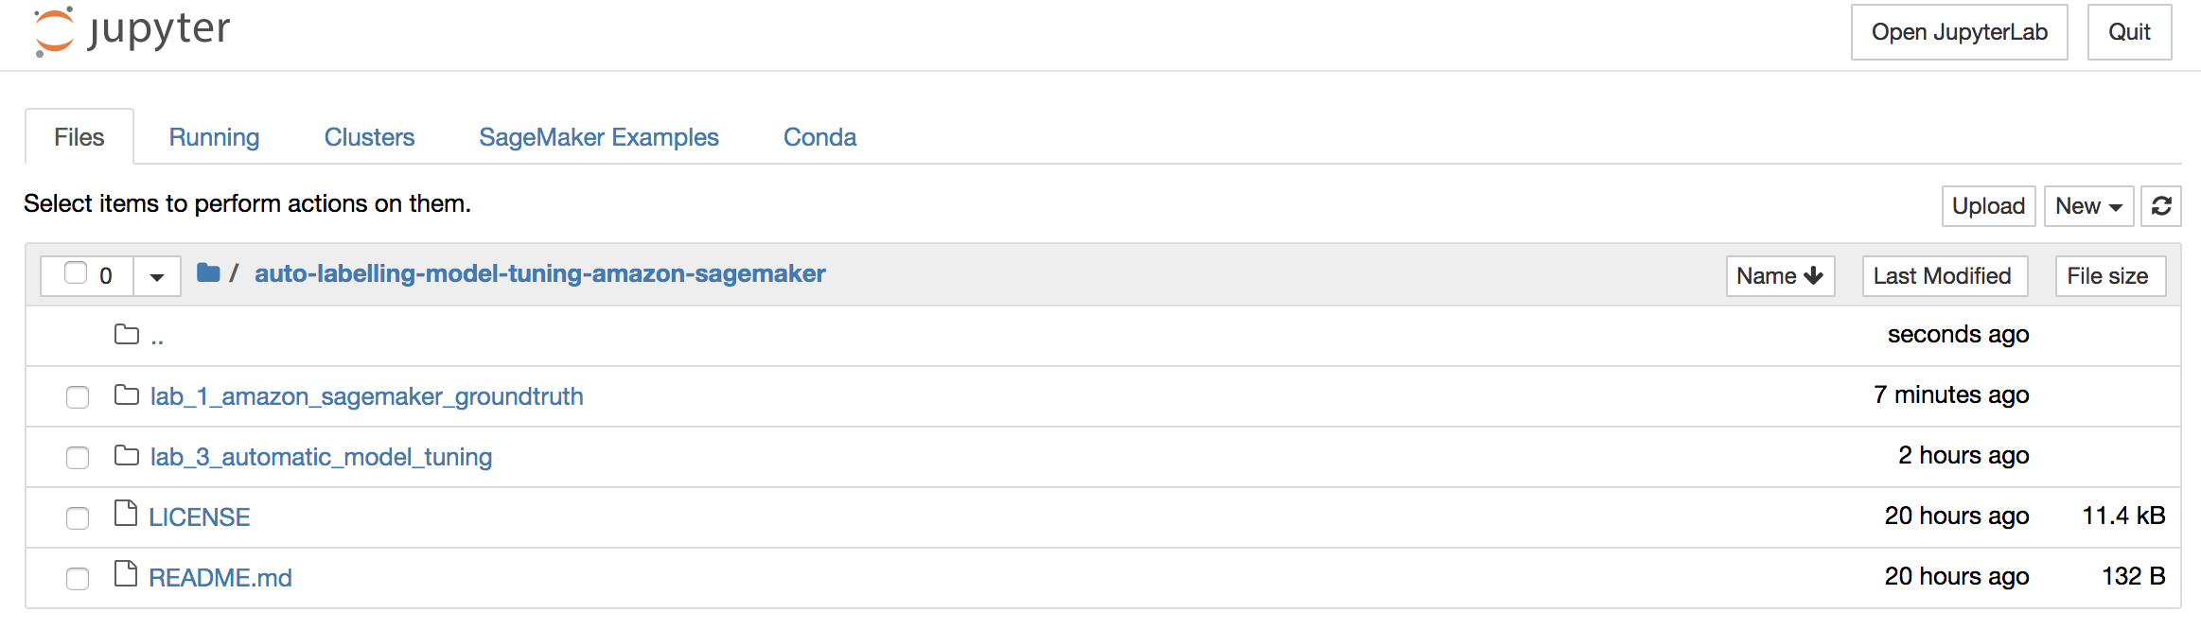
2. Click on the lab_1_amazon_sagemaker_groundtruth folder, and launch the **object_detection_tutorial.ipynb notebook** by double clicking on it.
3. If prompted Choose “Conda_Python3”

### 5. Running the Notebook

Run all of the cells in the “Introduction” and “Run a Ground Truth labeling job” sections of the notebook. You need to modify some of the cells, so read the notebook instructions carefully. Running these sections:

Creates a dataset with 10 images of birds

Creates object detection instructions for human annotators

Creates an object detection annotation job request

Submits the annotation job request to Ground Truth

The job should take about 45 min.

When it’s done, run all of the cells in the “Analyze Ground Truth labeling job results” and “Compare Ground Truth results to standard labels” sections. This produces a lot of information in plot form.

We will also demonstrate the results on the screen of a labelling job using 1,000 images. This takes approximately 4 hours to run. Optionally set RUN_FULL_AL_DEMO = False in the notebook to run this yourself after the workshop.

The labelling job itself will take about 15min as it is going out to a team of humans to label. While this is running follow the instructions in the notebook to create the same labelling job using the console to facilitate your understanding of the process.



You should be able to check the status of the labelling job in Amazon Sagemaker->Labelling Jobs



## Lab 2 - Create a private team to test your task

This step requires you to use the AWS Console. However, we **highly recommend** that you follow it, especially when creating your own task with a custom dataset, label set, and template.

We will create a private workteam and add only one user (you) to it. Then, we will modify the Ground Truth API job request to send the task to that workforce. You will then be able to see your annotation job exactly as the public annotators would see it. You could even annotate the whole dataset yourself!

To create a private team:

1. Go to AWS Console > Amazon SageMaker > Labeling workforces
2. Click "Private" and then "Create private team".
3. Enter the desired name for your private workteam.
4. Select "Create a new Amazon Cognito user group" and click "Create private team."
5. The AWS Console should now return to AWS Console > Amazon SageMaker > Labeling workforces.
6. Click on "Invite new workers" in the "Workers" tab.
7. Enter your own email address in the "Email addresses" section and click "Invite new workers."
8. Click on your newly created team under the "Private teams" tab.
9. Select the "Workers" tab and click "Add workers to team."
10. Select your email and click "Add workers to team."



1. The AWS Console should again return to AWS Console > Amazon SageMaker > Labeling workforces. Your newly created team should be visible under "Private teams". Next to it you will see an ARN which is a long string that looks like arn:aws:sagemaker:region-name-123456:workteam/private-crowd/team-name. Copy this ARN into the cell below.
2. You should get an email from no-reply@verificationemail.com that contains your workforce username and password.
3. In AWS Console > Amazon SageMaker > Labeling workforces > Private, click on the URL under Labeling portal sign-in URL. Use the email/password combination from the previous step to log in (you will be asked to create a new, non-default password).

This is how the Labelling job console will look like for Private workforce

That's it! This is your private worker's interface. When we create a verification task in [Verify your task using a private team](https://inference-demo.notebook.us-east-1.sagemaker.aws/examples/preview?example_id=%2Fhome%2Fec2-user%2Fsample-notebooks%2Fground_truth_labeling_jobs%2Fground_truth_object_detection_tutorial%2Fobject_detection_tutorial.ipynb#Verify-your-task-using-a-private-team-[OPTIONAL]) below, your task should appear in this window. You can invite your colleagues to participate in the labeling job by clicking the "Invite new workers" button.

The [SageMaker Ground Truth documentation](https://docs.aws.amazon.com/sagemaker/latest/dg/sms-workforce-management-private.html) has more details on the management of private workteams.

Once the private workforce is created ,go to the Jupyter notebook and run the remaining instructions .

## Lab 3: Automatic Model Tuning with Amazon SageMaker

## Finish –Cleanup

1. Stop your Sagemaker notbook
   1. Once stopped, Delete if you no longer want the lab notebooks.
2. Delete S2 bucket and contents
3. Delete Cognito Userpool